**Project Design Phase-II**

**Data Flow Diagram & User Stories**

|  |  |
| --- | --- |
| Date | 9th April 2025 |
| Team ID | SWTID1742986012 |
| Project Name | Survey Form |
| Maximum Marks | 4 Marks |

**Data Flow Diagrams:**

A Data Flow Diagram (DFD) is a traditional visual representation of the information flows within a system. A neat and clear DFD can depict the right amount of the system requirement graphically. It shows how data enters and leaves the system, what changes the information, and where data is stored.

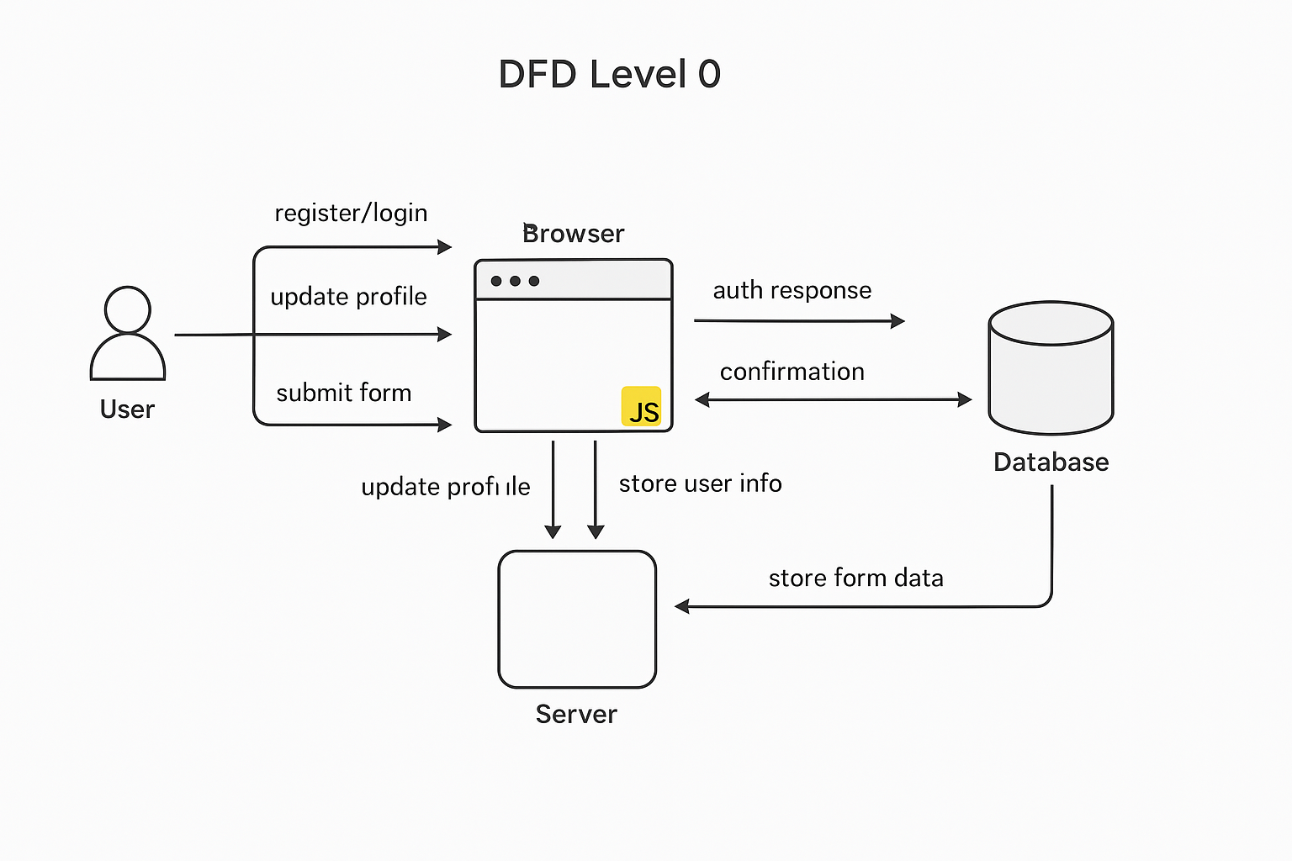

**User Stories:**

| **User Type** | **Functional Requirement (Epic)** | **User Story Number** | **User Story / Task** | **Acceptance Criteria** | **Priority** | **Release** |
| --- | --- | --- | --- | --- | --- | --- |
| **Customer (Mobile user)** | **Registration** | **USN-1** | **As a user, I can register by entering my email, password, and confirming password** | **I can access my account/dashboard after successful registration** | **High** | **Sprint-1** |
|  |  | **USN-2** | **As a user, I will receive a confirmation email once registered** | **I can receive confirmation email & click confirm** | **High** | **Sprint-1** |
|  |  | **USN-3** | **As a user, I can register using Facebook login** | **I can register & access dashboard with Facebook** | **Low** | **Sprint-2** |
|  |  | **USN-4** | **As a user, I can register using Gmail** | **I can register & access dashboard with Gmail** | **Medium** | **Sprint-1** |
|  | **Login** | **USN-5** | **As a user, I can log in using email and password** | **I am redirected to dashboard after successful login** | **High** | **Sprint-1** |
|  | **Dashboard** | **USN-6** | **As a user, I can view my profile and update personal details** | **My updated data is reflected in my profile** | **High** | **Sprint-2** |
|  | **Dashboard** | **USN-7** | **As a user, I can fill and submit a survey form** | **Submitted data is stored securely in the backend** | **High** | **Sprint-2** |
|  | **Dashboard** | **USN-8** | **As a user, I can view a confirmation message after submitting a survey** | **A toast notification confirms the survey was submitted** | **Medium** | **Sprint-2** |